
- Normal
- Heading 1
- Heading 2
- Heading 3
- Heading 4
- Heading 5
- Heading 6
- Code Block
- Default
- Arial
- Georgia
- Impact
- Tahoma
- Times New Roman
- Verdana
- arial
- Default
- 8
- 9
- 10
- 11
- 12
- 14
- 16
- 18
- 24
- 30
- 36
- 48
- 60
- 72
- 96
- Default
- Lower Alpha
- Lower Greek
- Lower Roman
- Upper Alpha
- Upper Roman
- Default
- Circle
- Disc
- Square
- Default
- Single
- 1.15
- 1.5
- Increase
- Decrease

3-6357-254-00_01. Introduction to the Lab Environment
Objectives
On completion of this module, you should be able to:
- Define the details of the lab environment.
Lab environment overview:
This on-demand course includes two components: the personal lab environment and the interactive learning material. (Added a colon after 'components' to introduce the list of components.)
The personal environment can be accessed from your laptop using a token-based login. (No corrections needed.)This token was generated by the OpenText learning services team and sent to you via email prior to the start of the course. (Added 'the' before 'OpenText learning services team' for clarity.)
Before diving into the content, it is important to understand and test the lab environment.
Connection
- The connection to the lab is done through the learning portal and it is accessible through a normal Internet connection. If you are unable to connect, switch to another Internet source or turn off the corporate VPN.
- The connection works best with Chromium-based web browsers such as Chrome, Vivaldi, Edge, Chromium, and Opera. (Changed 'Web browsers' to 'web browsers' for consistency and correctness.)
- The recommended resolution for the lab is 1920x1080 without UI Scaling. This ensures that all OPSB components are displayed as intended, without the need to scroll or zoom out.
When connecting, a new tab opens in your browser, and you will be requested to allow access to your clipboard. (Added a comma after 'browser' for better readability.) The course will include many copy-paste actions that save time (allow clipboard access). (Changed 'allow the clipboard access' to 'allow clipboard access' for conciseness.) The permission is valid only for the length of the session and will need to be granted with every connection. (Changed 'at every connection' to 'with every connection' for better readability.)
The newly opened tab includes a remote desktop connection to your individual student environment. (Added 'a' before 'remote' to maintain proper grammar.)
Your initial RDP connection will be to the Access VM (AVM), from which you can connect to the internal lab environment components—referred to as the Lab Machines.
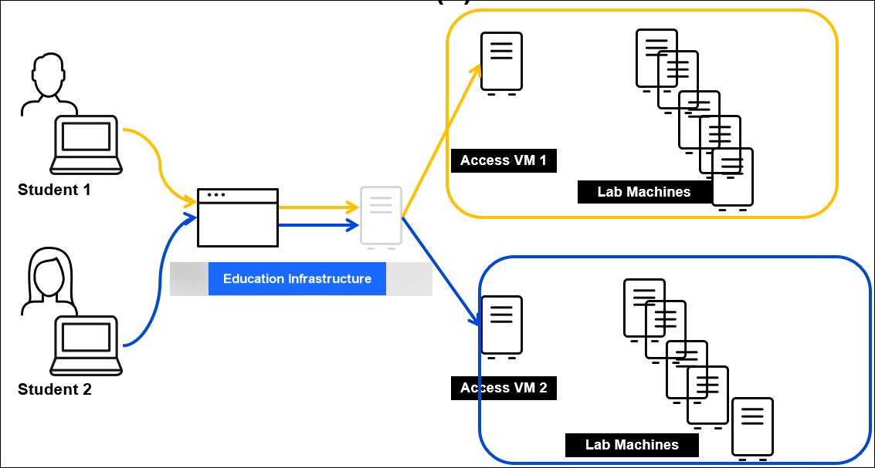

- Each AVM can connect to its own set of servers that are used in the lab.
- The servers are based on Windows and Linux OS types.
- Students cannot operate each other’s servers.
- In many cases, the hardware is not shared between student environments; therefore, the workload of one student will not affect other students.
The AVM is the host that runs all the lab servers in Hyper-V. (Remove the extra space before 'Hyper-V'.) The VMs in Hyper-V are configured to return to the last state before the AVM was powered down. (Correct the misspelling of 'Hypoer-V' to 'Hyper-V'.)When you log in to the AVM for the first time each day, the VMs will take about 20 minutes to be fully operational. (No changes needed.) Validate that the VMs are running before starting the exercises. (No changes needed.) The lab exercises for this module will show which VMs need to be powered up and which ones can stay powered down. (No changes needed.)
To stay cost effective, the AVM and its internal VMs will be powered down at the end of the day automatically.
During the course, you will receive instructions such as Open an overview application (Lowercase 'an' and remove the space before 'Application'.) or Run a command (Change 'Execute' to 'Run' for active voice.).As the lab environment can include up to 17 servers, those instructions can apply to more than one server.
To avoid the confusion, the instructions follow this structure:
- Any instructions that ask you to open an application, access a URL, or 'connect to a server' should be executed from AVM. (Added single quotes around 'connect to a server' to maintain consistency with the style guide.)Example 1: OBM should be opened in Chrome only on the AVM. To do this, launch Chrome on the AVM and navigate to the OBM URL. (No changes needed.)Example 2: Connecting to the OBM server via SSH must be done only from the AVM using the provided tool. Do not attempt to run the SSH command from any other Linux server. (No changes needed.)
- Instructions that ask you to perform an action on one of the internal servers will include a specific request to do so in a non-default location. (Changed 'one of the internal servers' to 'a non-default location' to maintain the original meaning.)Example 1: Opening https://opsb-obm.itomlabs.com:29292 inside OBM’s server RDP should be executed by connecting to the OBM server through RDP, and then the URL can be opened in the OBM server’s browser. (Changed 'OBM’s server browser' to 'OBM server’s browser' to maintain the original meaning.)Example 2: Copying the files from OBM to NFS servers by using 'scp 1.txt root@nfs:/tmp' should be executed on the OBM server. (Changed 'scp 1.txt root@nfs:/tmp should be executed on the OBM server' to 'scp 1.txt root@nfs:/tmp' should be executed on the OBM server' to maintain the original meaning.)

Using mRemoteNG
mRemoteNG is a GNU-licensed RDP and SSH client that allows you to connect to multiple RDP and SSH sessions in tabs. This is the primary tool for accessing the internal lab servers from AVM. (Added a period after 'tabs' to improve readability.)
To open mRemoteNG with administrative privileges, right-click the mRemoteNG icon—either on the desktop or in the C:\EduServices folder—and select Run as administrator from the context menu. (No corrections needed. The text is already clear and follows Microsoft Style Guide principles.)
The left pane displays a list of servers in two categories and each connection can be opened by double-clicking on an entry in the list.
Connect to all relevant lab machines at the beginning of the week to see if all of them are functioning.
You can close the opened connection by double-clicking the Connection tab.
In some scenarios, you will need to open multiple connections to the same server to speed up the Lab tasks.
To open a duplicate session, right-click the tab and select Duplicate Tab.
Watch this demo video to see it in action:
Using mMremoteNG - File copy (Hyphenated compound words should use a hyphen, not an en dash.)
When you need to copy files between AVM and one of the internal servers, File copy there are several options available:
RDP (up to 2 GB):
Find a file on AVM and press CTRL+C to copy it.
Access the required RDP session and navigate to the required target folder.
Press CTRL+V to paste the file. (No errors found.)The file will transfer from AVM to the RDP session. (No errors found.)
Do not use copy/paste until the file copy has ended.
RDP for files larger than two GB:
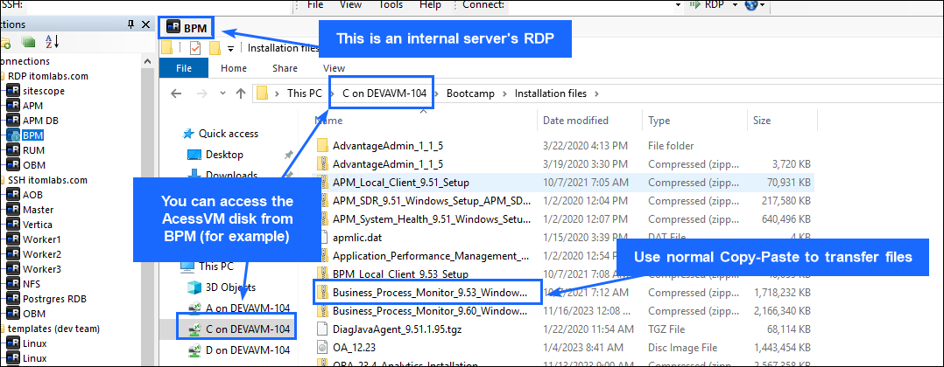

- Connect to the required RDP session.
- Open the File Explorer.
- You can access the AVM file system directly from inside the internal servers.
Transfer files from AVM to Linux servers:
- Right-click the required Linux server in the mRemoteNG navigation tree.
- Select External Tools > File Transfer.3. Use drag-and-drop or normal copy/paste between the AVM and Linux server to transfer the files.
Pro Tip: For a Windows-like experience when working with Linux applications, use WinSCP to open and edit text files directly on the Linux system. (No errors found.)
Watch this demo of the file transfer process:

Lab environment servers
The IP addresses and DNS records will be repeated in lab exercises. There is no need to keep them in a separate note. (No errors found.)
Operating System Credentials:
Linux:
- Username: root
- Password: L1nW1nos_pass (No errors found.)
Windows:
- Username: administrator
- Password: L1nW1nos_pass (No errors found.)
IP Address
Hostname (DNS)
OS Type
172.16.11.59
opsb-opscx.itomlabs.com
Windows
172.16.11.20
opsb-aob1.itomlabs.com
Linux
172.16.11.21
opsb-sitescope.itomlabs.com
Windows
172.16.11.18
opsb-bpm.itomlabs.com
Windows
172.16.11.52
opsb-postgres.itomlabs.com
Linux
172.16.11.5
opsb-master.itomlabs.com
Linux
172.16.11.50
opsb-obm.itomlabs.com
Linux
172.16.11.3
accessvm.itomlabs.com
Windows
172.16.11.10
opsb-apm.itomlabs.com
Windows
172.16.11.12
opsb-apmdb.itomlabs.com
Windows
172.16.11.7
opsb-vertica.itomlabs.com
Linux
172.16.11.61
opsb-worker1.itomlabs.com
Linux
172.16.11.62
opsb-worker2.itomlabs.com
Linux
172.16.11.63
opsb-worker3.itomlabs.com
Linux
URLs and credentials
Summary
This module presented the following topics:
- Defined the details of the lab environment.


Oh no!
Please try again later, contact LearnExperts if the problem persists.

